Deployment Guide

1. Please unzip the “TaskAppGEICO source code” file and open using Visual studio(VS2022 was used to code this and dot net code 3.1 was the framework )

2. Unzip the “GEICOTEST DB” file. Please try to restore the “GEICOTEST.bak” file or you can run the SQL script “GEICOTEST SQL script.sql” file if restoring the backup file didn’t work. You should be able to see a DB called GEICOTEST with 3 tables “TaskPriority”, “TaskStatus”, and “TaskTable”. Refer to the attached DB.jpg

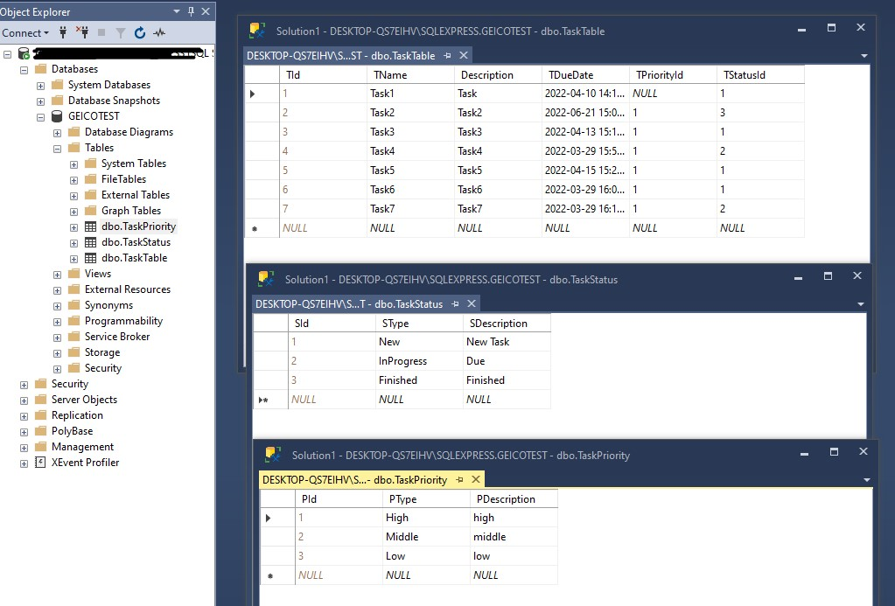

3. Please go to the “appsettings.json” file and update "DbConnection" according to your SQL server credentials

"DbConnection": "Server=your_Server_Name;Database=Your_DB_Name;Trusted_Connection=True;",

Your connection string may differ as I was using only windows authentication. I have used MSSQL express 2019.

4. Please be sure that the following NuGet packages are installed. Pay some attention on the versions as some of the latest’s are only work with.NetCore 6

· Microsoft.EntityFrameworkCore.SqlServer V.5.0.15

· Microsoft.EntityFrameworkCore.Tools V.5.0.15

· NSwag.AspNetCore V 13.10.12

Refer to the NuGet packages.jpg

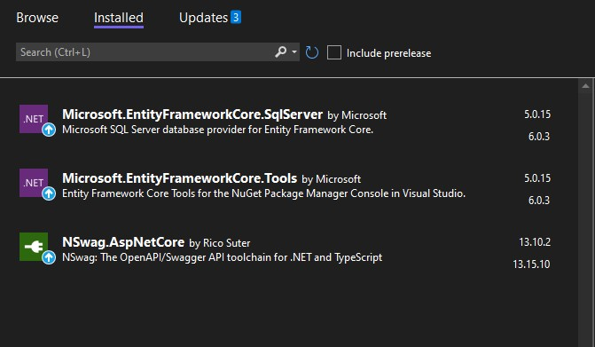

5. Once you change the DB connection, run the solution and it should work and prompt a Swagger index page with

· AddTask

· UpdateTask

· GetTasks

Refer to the attached “Swagger Page.jpg”

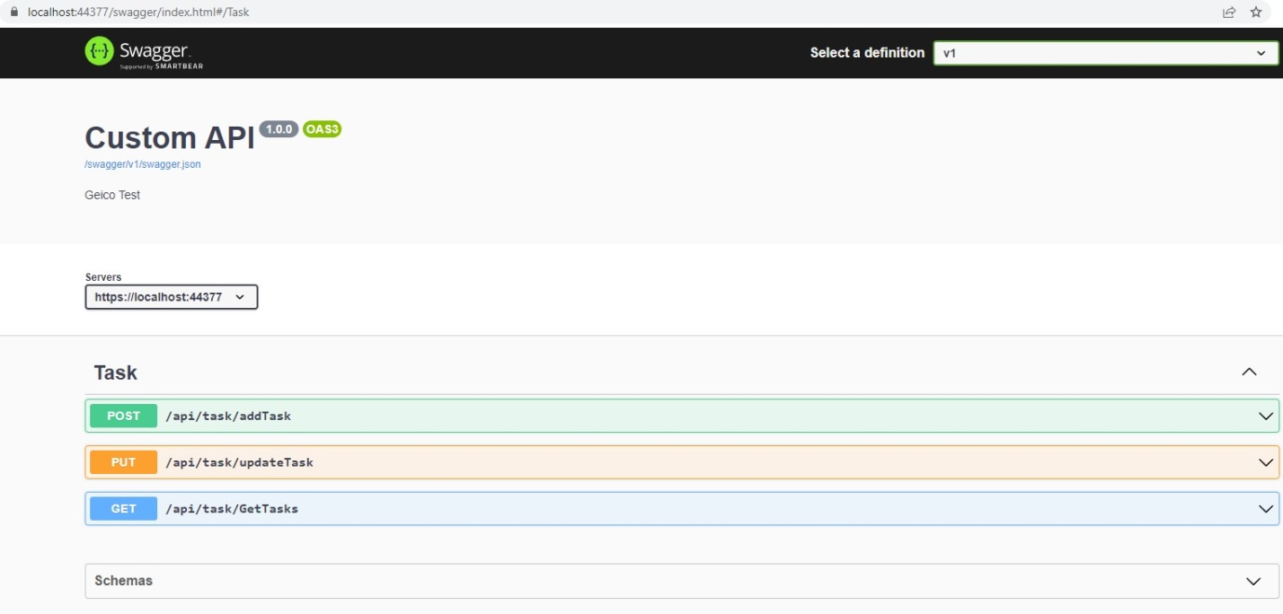

Click on the task and expand it. Click “Try Out” button

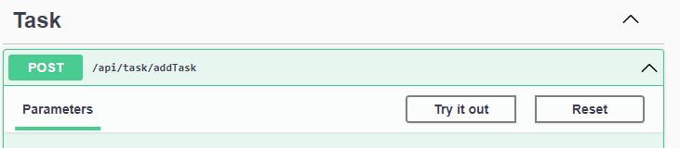

then “Execute” button after enter/modify the json parameters

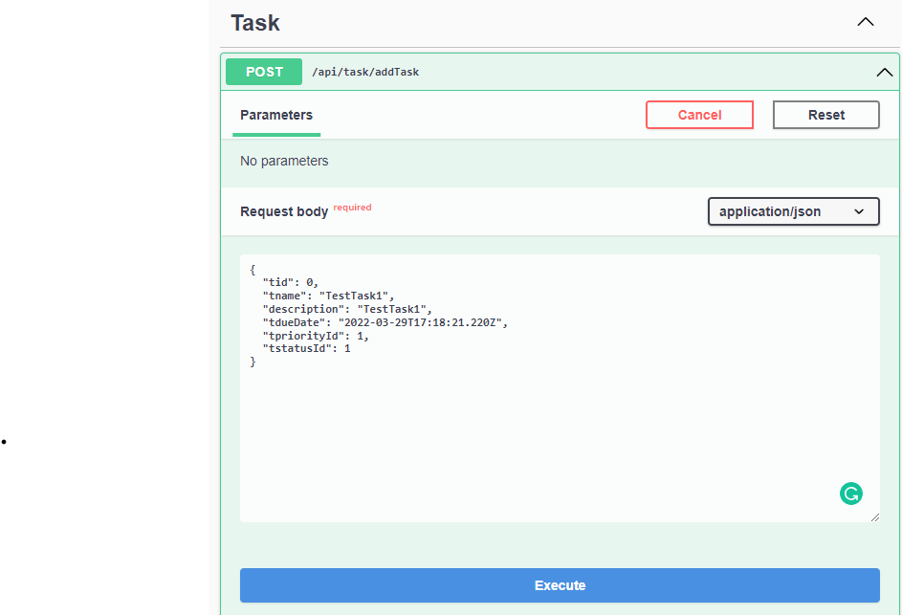

You can test the solution with getting task and see whether you can see all the tasks in the TaskTable table in the DB. Refer to the attached “Swagger Task Get data.jpg”

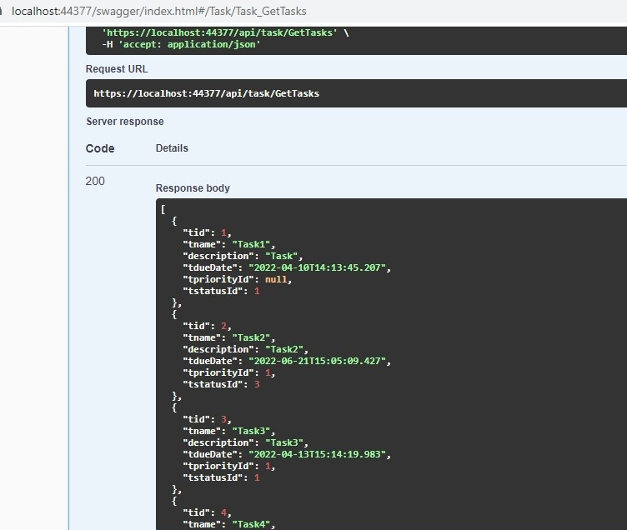

Please try to add task, update task and get tasks that you added or updated. Please go through the comments and I hope I have added more comments to describe what I have done. Please reach out to me at [shammakalubo@gmail.com](mailto:shammakalubo@gmail.com) for any additional information.

Thanks

Shameera Kalubowila.